**Gathering Information for Exploring Brunel**

Gathering the information about all the buildings in Brunel university campus and integrating them in to our app in a useful and understandable manner is critical for the usability of our app. As we know there are various buildings wit in Brunel campus and all the offices, departments and facilities are held within them.

The idea is to have all the buildings first and then go to what is inside them. Let’s keep in mind that it is not only about buildings open spaces might be of interest.

**Buildings**

Gathering the information on all the buildings in the Brunel campus is the first task with the data on each building including

Name of the Building

Front picture of the building if available

Short background information (history) of the building

We are just talking about the physical structure of the building we have not gone inside yet.

We have decided in our meetings that our app should have the capacity to search a place using a search tab or directly go in to the map.

The idea of having all the buildings a clickable icon is a good way for users to have direct access to information about buildings.

I will try to illustrate it using a picture. But, keep in mind the design I am using is for illustration purpose not a true representation of how our app will look like.

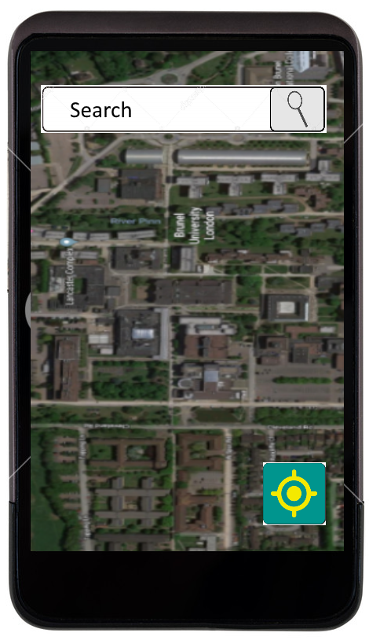

Figure 1. The home page of the app either you can search a location or directly access the map

When directly accessing the map, the buildings will have a clickable icon that displays the name of the building when tapped once and displays a more detailed information in another page.

For example. Let’s see what happens when a user opts for direct map access and taps the icon on **Wilfred Brown** building.

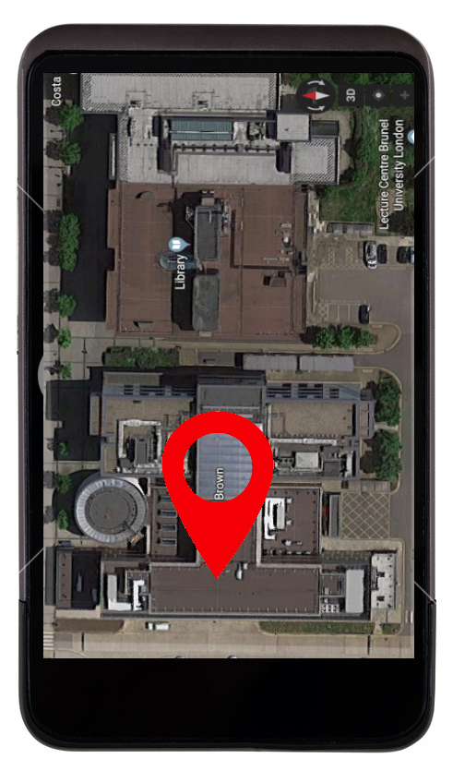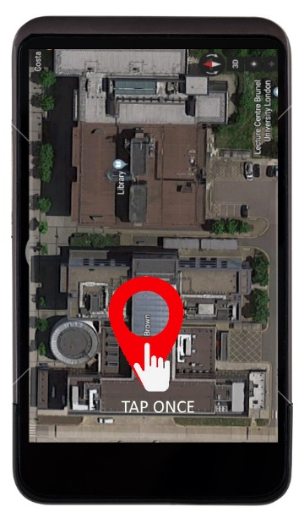

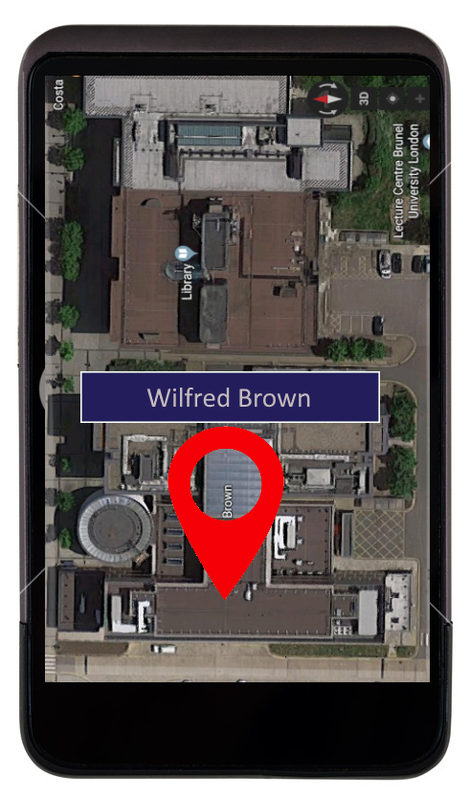 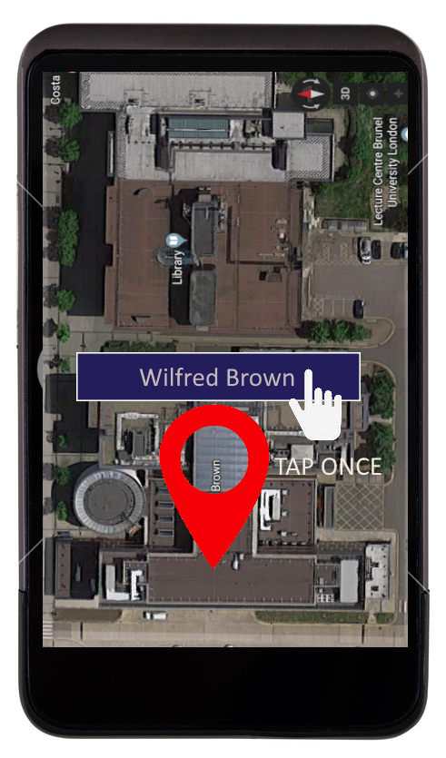

Tapping on the bar will take the user to another page that displays the information about **Wilfred Brown.**  There is a very good model on the Brunel University Virtual Tour website (https://www.brunel.ac.uk/virtualtour/?filter=academic) that we can adpot.I will use that model for the illustration purpose.

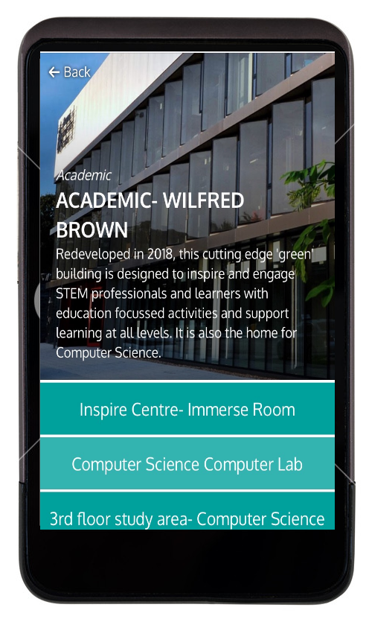We can see that the new page displays a brief information regarding the Wilfred Brown building and lists all the components of the building underneath.

Tapping on one of the components displays a 360 degrees image of the components. In our case we can add additional information on top of the image when it is necessary.

For example, if we select **Computer Science Computer Lab** out of the list we can just display a virtual image as there is no much information that we can portray. However, if someone selects **Computer Science Department** we can put additional information like.

**Floor**

**Room Number**

**Telephone number**

**Website**

**Email**

**etc.**

So, which information we display depends on the importance of the office or facility to users or we can be selective to limit the information we put in our database or we can limit the list to the most important offices or facilities with in a building.

**So far, we have only seen direct access through the map. Let’s see how the app behaves when we search a location in the search tab. It will not be much different the app will take us directly to the building where we can tap the icon to get more information as we have seen above.**

**Conclusion**

What I have tried to do is how we should we display the information and what type of information should we display in our app that we think is helpful. To start with**, I believe we should gather as much information as possible on all the buildings whether it be academic, accommodation or public spaces** and we can decide which of the information we should use. I will contact our tutor on how we can obtain those data and what the requirements are.

We can advance from this to how we should integrate our app to calculate the best route between current location of a user and destination.